* Design a network with two subnets,

1. 192.168.1.0/24 in left hand side
2. 192.168.2.0/24 in right hand side

* Change the hostname of the router.

Hostname: yourname

* Put enable password both plain text and encrypted

To provide password in Cisco router

1. enable password (password) - plain text (yourname)

2. enable secret (password) – encrypted (yourname)

* Configure according to the picture below and ping from 192.168.1.1 to 192.168.2.3.
* 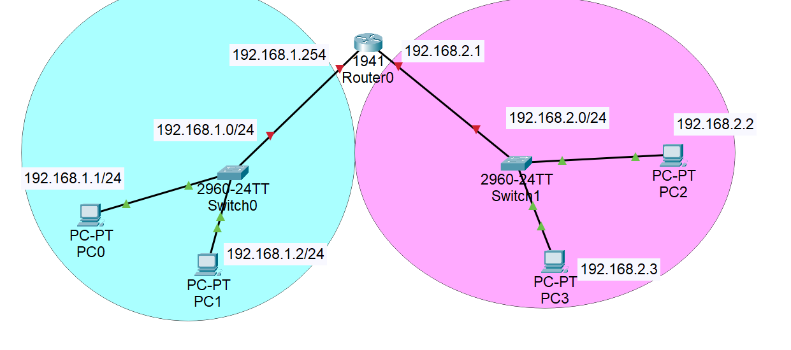If ping gets reply then good else troubleshoot.